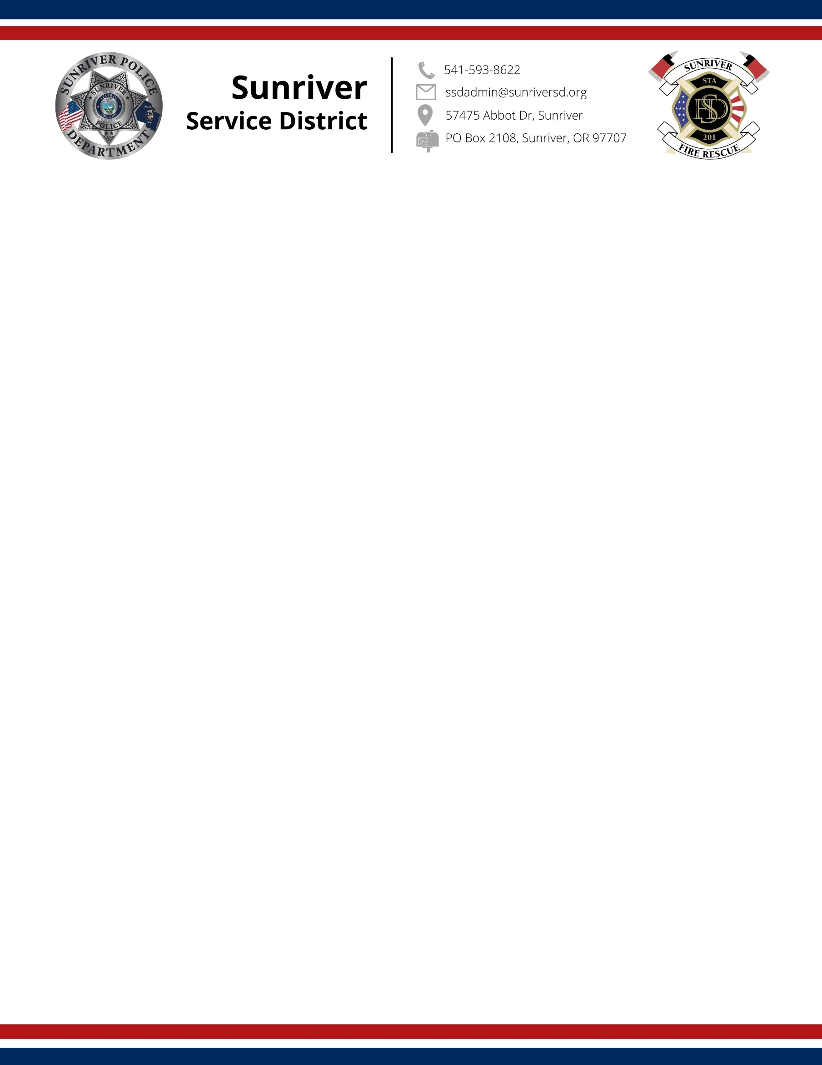

Seator Hall Training Room, Public Use Policy

Purpose
Seator Hall is the public room and training center in the Sunriver Service District Public Safety Building. The District allows public use of certain facilities in a manner that is reasonable and consistent with District policy. Visitors are allowed in District facilities, subject to limitations described in this policy. Visitors to District facilities should always be treated in a courteous and professional manner. The room is provided to support meetings, training sessions, and community programs that align with the mission of the District. Use of the room must not interfere with regular building operations or public safety. liability enforcement to the first line, the reserving party is financially responsible for any damages the district reserves the right to collect a cleaning fee in advance

Availability
At this time, the conference room is available during regular business hours, Monday through Friday, 9:00 AM to 4:00 PM. It is not available on weekends, holidays, or outside these hours. Visitors are allowed on District property as long as their presence does not interfere with District operations.

Supervisory personnel may restrict visitors on non-official business when their presence interferes with a planned activity or District business. Children under 18 are not allowed in District facilities, unless accompanied by a member of the District or other adult.

Liability and Enforcement Policy
The reserving party shall be held financially responsible for any damages incurred during the use of district facilities. The district reserves the right to enforce this liability by collecting a cleaning and/or damage deposit in advance of the scheduled use.

Eligibility and Priority of Use
Priority Order:
- Sunriver Service District official meetings and events.
- Other government agencies or groups with broad public interest, including but not limited to school districts, special districts, public safety organizations, and the like.
- Elected officials, excluding campaign-related activities.
- Designated not-for-profit 501(c)(3) organizations
- Public use by individuals, private groups, or community organizations.

Public eligibility and restrictions:
The room may be used by political parties but must not be used for the purpose of endorsing a political candidate or measure. No political material may be displayed in the room.

The room may not be used for gambling of any type.

Events that involve the subject or use of drugs, alcohol, or lascivious conduct are not permitted.

Exceptions to the above are permitted with the written permission of the District Board Chair or specific designee.

The District reserves the right to “bump” scheduled events to accommodate emergent District or emergency services needs.

Reservations
How to Reserve:
Call the Sunriver Service District at 541-593-1014 to make a reservation.
Advance Notice: Reservations must be made at least 5 business days in advance.
Time Limit: Maximum of 4 hours per day per group unless approved otherwise.
Cancellations: Must be made at least 24 hours in advance.
The reserving individual must be at least 18 years of age.
A responsible party must be present during the entire event.

Room Use Guidelines
No admission fees, commercial sales, or fundraising without prior approval.
The room must be cleaned and restored to its original setup after use.
No alcohol, smoking, open flames, or incense.
Food and non-alcoholic beverages are permitted with proper cleanup.
Noise must be kept to a level that does not disturb others.
Children must be supervised at all times.

The District building has five public parking spaces available. Use of more parking spaces must be coordinated at the time of reservation with the Sunriver Owners’ Association for use of their parking lot.

Setup and Equipment
Tables and chairs are available for use. Furniture outside the training room may not be used or moved.

A/V equipment must be requested in advance. No A/V support is available beyond basic setup.
All setup and takedown must occur within the reserved time.

Liability and Enforcement
The reserving party is financially responsible for any damages.
Repeated violations may result in loss of access privileges.
The District may, at its discretion, request a liability waiver for activities in the room.
The facility reserves the right to cancel reservations for policy violations or operational needs.

Contact for Reservations
Sunriver Service District
541-593-1014
ssdadmin@sunriversd.org

Approved by SSD Board via Resolution 2025-009 on June 19, 2025.

